Community Assessment Report

Student’s Name
Institution
Date

Community Assessment Report
Identifying the Health Need
The health policy framework of California introduced a new type of health practitioner referred as the family health nurse. The family health nurse will specifically be located in Fresno County (The County of Fresno, n. d.). This nurse will play a significant role along the entire disease continuum and throughout the life course, alongside a specific reference to the health needs of the most vulnerable population within the state of California (Drennan & Williams, 2018). A family health nurse will have an extensive knowledge towards the determinants founded on the practice regarding public health principles and primary health care. In order to enhance their role more effectively and plan their work accordingly, these nurses will need to have a full understanding of the society alongside their health needs (Christensen & Kenney, 2015). Also, they will need the necessary competencies to evaluate individuals and families with their health and associated needs, allow a combined plan. As a result, they will be needed to be capable to partake societal, family and individual needs assessment.
Demographic Characteristics
Assessing age distribution of the society was importance because this will have major influence on family health needs. A number of profile tended to divide the community comprising of the following age bands; elderly people, adults, pre-school children, young people and school-age children (Christensen & Kenney, 2015). In the latest 2020 census of the United States, Fresno County had a population of 1,012, 748 people. Out of this, about 130,475 were in the elderly age, which begins from 65 years (Healthy Fresno County Data, 2021). About 78,895 are in the preschool age while about 30% of the population is made up of the young people (Healthy Fresno County Data, 2021). The school-age children represented about 28% of the population. The age distribution is as indicated below.
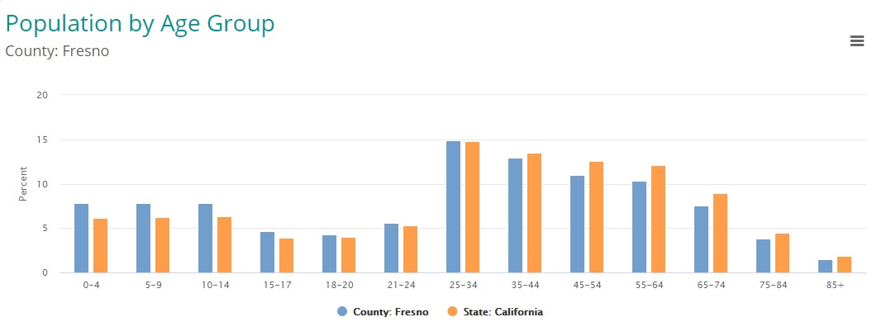
After the collection of data, it was discovered that young people and the old population had higher level of health care needs. Factors such as lack of health insurance has played a significant role in contributing to this healthcare need. However, this is not to suggest that this community had greater dependent population among elderly people and many children. This is when using many resources to care among these populations, instead such groups tended to choose to make large investments in regards to invest their resources when caring for the health needs of adults because of their ability to function and work to maintain these dependent populations (Drennan & Williams, 2018).
Patterns or Trends
Most illnesses and disease patterns were closely associated with economic circumstances among the populations, and thus the identified health need appeared to affect individuals with poor economic status (Griffiths, 2010). Health statistics discovered that, even among populations whose death rates appeared to improve illnesses or diseases, poorer communities or ethnic populations such as African Americans suffered more from the lack of family related health practitioners. This means that it will be important for family nurses to record trends of health inequality in the community. Ethnic groups were also classified based on factors such as nationality, religion, racial origin and color. Population patterns and trends was important because it will help nurses to identify any needed health services and patterns of diseases (United States, 2020). Mortality data will help nurses to evaluate patterns of death using factors such as causes of death, gender and age. This was a basic measure and assessment used information from death certificates obtained from government-based electronic tools to study various diseases within the community.
Groups within the Community
The ratio of females and males in this community carried a major bearing on the health care needs of the community. More importantly, the distribution of sexual characteristics had an average patterns, for instance, more boys were born when compared to their female counterparts and the analysis found out that among the old age, there were more women than men. Assessing gender distribution was important because it affected a number of health services needed (Christensen & Kenney, 2015). Also, it helped to study health issues such as maternity, family planning and diseases such as ovarian cancer (Griffiths, 2010). Religious and minority ethnic populations such as African Americans were marginalized within the community and were coupled with issues such as lack of awareness. This assessment will help nurses to identify different cultural and ethnic groups within the society.

References
Christensen, P. J., & Kenney, J. W. (2015). Nursing process: Application of conceptual models. Mosby.
Drennan, V., & Williams, G. (2018). British Journal of Community Nursing, 6(7), 336-341. https://doi.org/10.12968/bjcn.2001.6.7.7065
Griffiths, P. (2010). A community of practice: The nurses’ role on a medical assessment unit. Journal of Clinical Nursing, 20(1-2), 247-254. https://doi.org/10.1111/j.1365-2702.2009.03135.x
United States. (2020). Technical Aids for Clinical Nursing: Annual. New York.

